PRODUCING A PERFUME/AFTERSHAVE BOTTLE ON PRO-DESKTOP

Step by step – words in “speech-marks” .are from the menu & drop-down selections
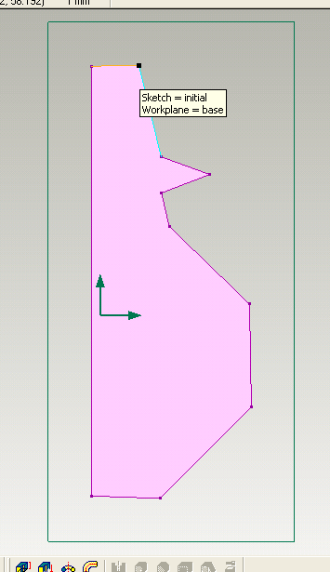
- Select “File”…… “New” …….“Design”
- Maximise the drawing screen, hold down shift & press W to view flat on to the workplane.
- Select the line drawing tool from the icons on the right of the screen, and draw a vertical line through the centre arrow, approx 100 mm long
- With this as a centre line, draw the outline of one side of a bottle shape. Try to make sure the base line, and the top line are at right angles to the centre line.
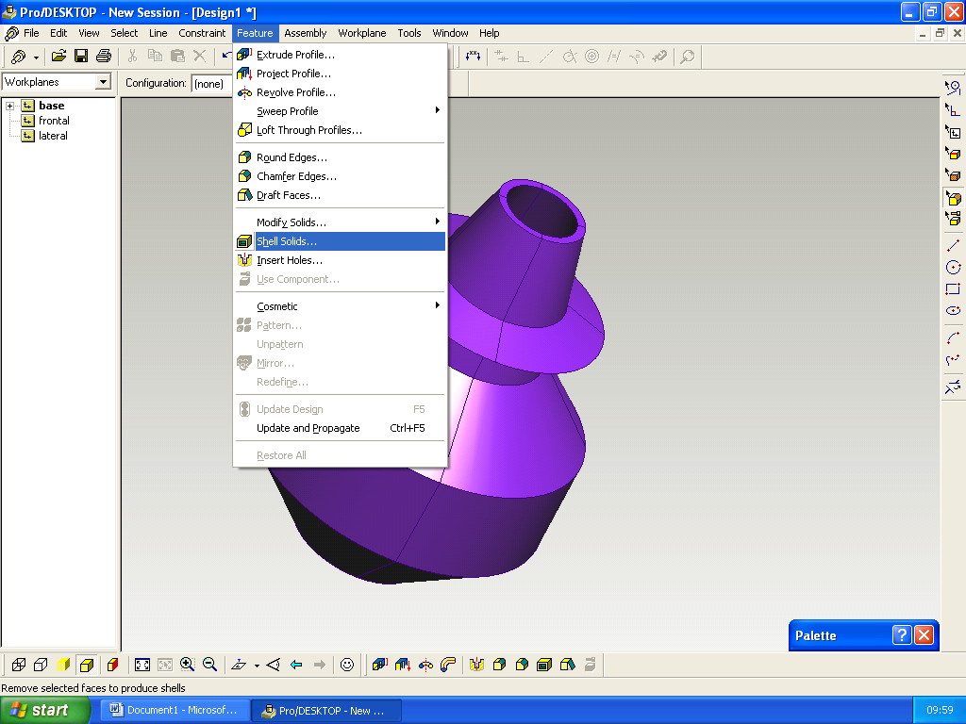
- To adjust the position of any line, pick the select line tool from the top of the icons on the right, click on the end of a line, and you can move it – use this to make the top & bottom lines at right angles to the centre.
- When you are happy with the shape, select the centre line, by clicking on it with the adjust line tool – it will go red.
- Select “Feature”……”Revolve Profile” in the box that appears, check you are adding material, above the workplane, and 360º.
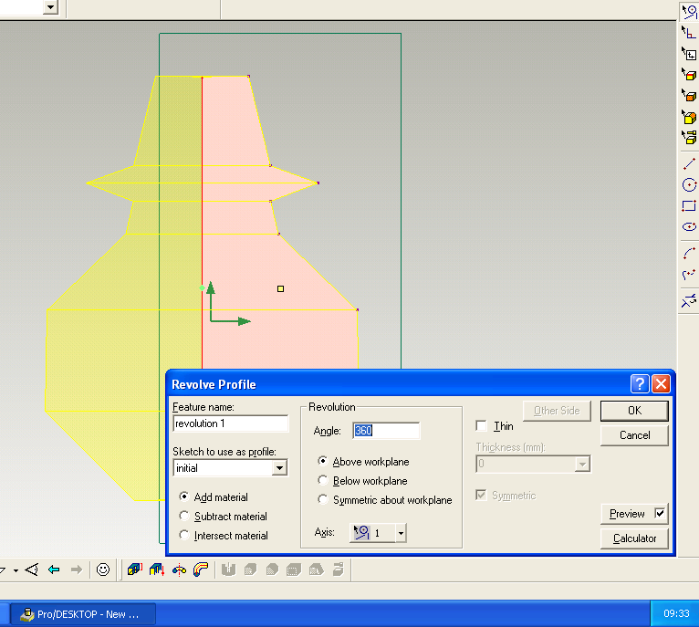
- Click OK, and a solid bottle should appear – if not, check you have first selected the centre line on the drawing.
- Save you first design by selecting “File”….”Versions”. Pick save now, give your file a name, and any comments to help remember it. Click OK and the bottle will be saved as version 1 – you can return to it by selecting versions again.
- Once you have saved the first version of your design, experiment with changing the shape – try using the arc tool to round corners – you may need to zoom in to do this. To zoom in, select “View”…..”Zoom in” and click&drag around the area to zoom in on. To return to the view of the whole bottle, select “View”….”Autoscale”
- Save each design you produce by selecting versions again – they will be saved as version2, version3 etc.
- To make your bottle hollow, select the top surface – do this by selecting “Select”…..”Faces” and clicking on the surface so that it changes colour. Then select “Feature”…….”Shell solids” and give an offset of 2mm – this will be the thickness of the sides. Click OK and your bottle will be made hollow (this will only work if the top is flat – the original line must be at right angles to the centre).

Extension work – As a new design, create a stopper with a tapered end like a cork you could do this the same way you did the bottle shape, or by extruding a circle with a 10º taper – make the top of the stopper an interesting shape (you could save different versions again). Assemble the stopper and bottle by selecting the circular edges , selecting “Assembly” and “centre axis”.

You could open the assembled bottle as a new album and add surface render – note that if you make the bottle glass, it is more effective if you create a flat surface for the bottle to sit on, like a table top – the glass then has something to reflect! – notice that you can tint the glass by colouring it.

